**DIFFERENTIAL MIMO SYSTEM**

**INTRODUCTION:**

The aim of this project is to generate four independent fading channels using Jake's fading Simulator and use the channels to simulate two different Differential MIMO Systems with 1 and 2 Receivers and study the Symbol Error Rate(SER) as a function of Symbol to Noise Ratio(SNR) using MATLAB.

**IMPLEMENTATION:**

1. A MIMO system with with *Mt* = 2 transmit antennas and *Mr* = 1 or 2 receive antennas.

The transceiver signal model in time is given by

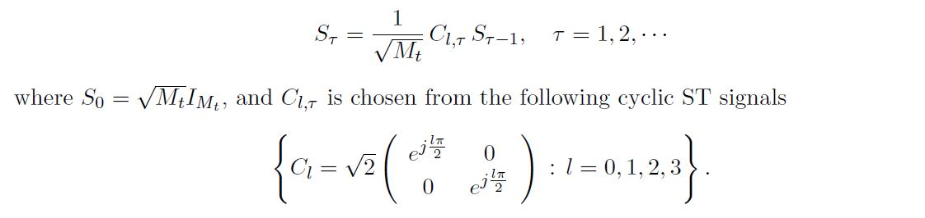

2. We assume that the fading channels are approximately the same over two adjacent transmission blocks H*T ≈* H*T-1* .

3. We assume a differential ST demodulation scheme such as:

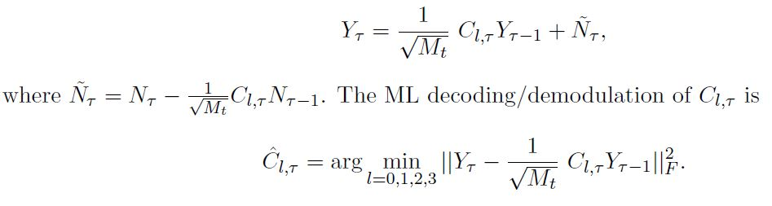

4. The MIMO system uses bandwidth of 30 KHz at the 800MHz frequency band, and a mobile user with moving velocity of 50 miles/hour. We also assume the slow fading channel experiences Rayleigh fading.

5. For the Jake’s Fading Simulator, we use M = 8 oscillators or N = 34 to generate four independent fading channels which will be used in the MIMO system simulations. 105 channel samples are generated for each channel considering normalized channel coeﬃcients such that the average power of each channel coeﬃcient is 1. In figure 1, the first 500 channel samples are plotted for the four channels by showing the Channel Amplitude in dB.

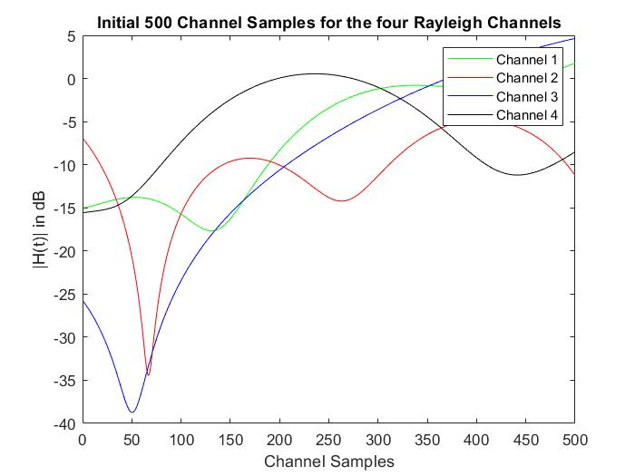

6. For *Mr* = 1, we use two fading channels generated in Part A to simulate the diﬀerential MIMO system and then plot the symbol error rate curve vs SNR.

7. For *Mr* = 2, we use four fading channels generated in Part A to simulate the diﬀerential MIMO system and then plot the symbol error rate curve vs SNR and then compare the two curves.

**OBSERVATION:**

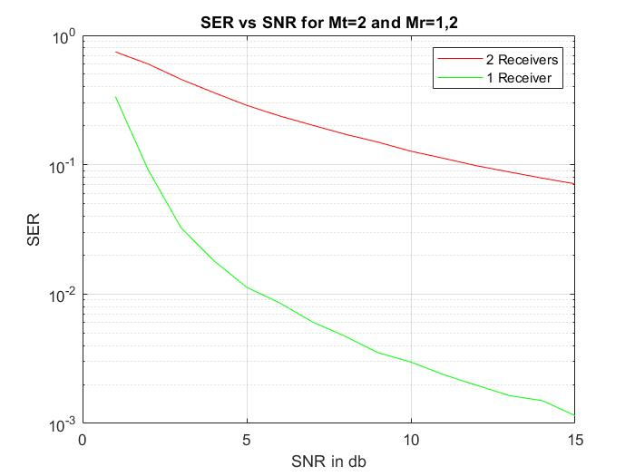

It is clear from the graphs that the symbol error rate of the MIMO system with 2 receivers is lower than that of the MIMO system with 1 receiver irrespective of the SNR. As the SNR increases, the gap in performance gradually increases between the two systems which is expected. Thus, it is evident that the MIMO system with 2 receivers outperforms the MIMO system with 1 receiver in terms of SER with respect to SNR.